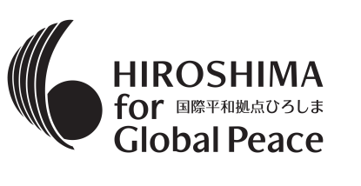
“UN７５ in Hiroshima” Application Form

Date of application:
First Name(s) |  | 【PHOTO here】  Size:  length 4 cm x width 3 cm  No hat/front of the upper body  Within 3 months  * Please fill in your name on the back of the photo  (If you send by mail).
Surname
Date of Birth
Tel
Mobile
FAX
E-MAIL | （Address that can receive attachments）
Address | Post Code:
English Proficiency | Qualification  The Eiken test grade  TOEIC score  TOEFL score  Others（ ）  *Please submit the copy of Official Certificates
- Overseas Experience
- Experience attending meetings in English
（Please fill in the country, period of stay, event name, etc.）
Acceptance by the Applicant | -If I am selected as a participant, I will work on the event independently and proactively.  - I accept that Hiroshima Prefecture will use the photos and videos of the event being held, and individual works created in the forum for public relations activities.  Applicants’ Signature  Date
Acceptance by the Parents  *For underage applicants | ・I confirm the above-mentioned statements, and agree that the applicant will participate if selected as a participant of this project.  Date  Address of the Parents:  Name of the Parents:  Relationship with the applicant:  Signature

◆What was your motivation for applying?（Please answer within the box below）

◆Self-Introductions（Please answer within the box below）

“How does disarmament contribute to the realization of the SDGs?”
At the “UN75 in Hiroshima”, we will discuss how disarmament contributes to the realization of the SDGs. You will be asked to summarize your thoughts, speak and make suggestions in English.

1. Please write your thoughts in English on the content proposed at the“UN75 in Hiroshima”.
(Around 1,500words, Up to 2 charts can be attached.)

Submit to
Peace Promotion Project Team, Regional Policy Bureau, Hiroshima Prefecture
10-52, Motomachi, Naka-ku, Hiroshima-shi, Hiroshima-ken, 730-8511
E-mail： chiheiwa@pref.hiroshima.lg.jp
TEL：：+81-(0)82-228-2368 FAX ：+81-(0)82-228-1614

The submitted personal information will be managed by the secretariat and will not be used for any purpose other than this activity and notification of various events held by Hiroshima Prefecture. Please contact the above immediately if any changes have been made to the submitted documents.

